**TDBA ATHLETE AWARDS**  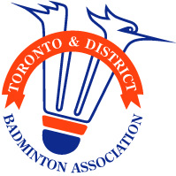

Application Deadline: May 31, 2025

TDBA Pursuit of Excellence Funding

Ontario B & C ranked players (B: 2 X $250 C: 2 X $250)

To Qualify, each applicant must be:

* U19 year of age (born 2007 or later)

Email applications to : [tdbapresident@gmail.com](mailto:tdbapresident@gmail.com)

By May 30, 2025

* B players, no more than 2999 OJRS points
* C players, no more than 1049 OJRS points

ALL APPLICANTS MUST SUBMIT THE FOLLOWING:

* Any volunteer work within the past 2 years, 2023-2025
* Proof of overall grade of at least 70% in 2024-2025 academic year, provide copy of present report card
* Explain why you deserve this award and how it will help you reach your goals (maximum 250 words)
* Proof of membership at a TDBA affiliated club for the year 2024-2025

Selection is based on cumulative total (OJRS, academic, volunteer work & explanation).

The TDBA Board of directors will review the applications and select the winners.

Recipients and the club’s owner will be notified that they will be receiving the award and the winners will also be posted on our website.